**A REPORT ON**

**Blender Environment**



Course Code : CCE 112

Course Title : Engineering Drawing

Session :2018-2019

*Patuakhali Science and Technology University*

[*Dumki*](https://www.google.com/search?client=firefox-b-d&q=Dumki&stick=H4sIAAAAAAAAAONgVuLWz9U3MDSwyMquTF_EyupSmpudCQCWwgSLFwAAAA&sa=X&ved=2ahUKEwiPybztydTjAhUPXisKHYoHBlgQmxMoATAfegQIChAK) *, Patuakhali – 8602*

**Date:29 July 2019**

**Blender Environment**

SUBMITTED BY

Md. Rakibul Islam

ID : 1802073

REG : 08483

SESSION : 2018-19

APPROVED BY

Md. Mahbubur Rahman Golam Md. Muradul Bashir

Lecturer Associate Professor

Faculty of Computer Science and Engineering

**PATUAKHALI SCIENCE AND TECHNOLOGY UNIVERSITY(PSTU)**

**ABSTRACT**

This is a report based on Blender Environment. In this purpose I got help from YOUTUBE tutorial to learn about Blender shortcuts, Design & how to do that. I look through as much tutorial to help myself for my needs. And also I got help from CCE class for beginner level of Blender.

Here I built a house with inside environment. I wanted to show how japanese rural house looks like from inside. So this project will benefit for study of house of the rural area, then they can improve those people from their current situation.

This document will discuss how “A Inside House Environment” was made with Blender v2.79b.

**DECLARATION**

I declare that this report presented in it is my own and has been generated by me as the result of my own original work.

I confirm that :

1.This work is done totally or mainly while in candidature for a degree at this university.

2.This report has not been previously submitted for at this university or any other educational institutes.

3.I learn various blender shortcut from youtube and see some beginner reference. Other than that this report and project is entire my own work.

APPROVED BY

Md. Mahbubur Rahman Golam Md. Muradul Bashir

Lecturer Associate Professor

Faculty of Computer Science and Engineering

**PATUAKHALI SCIENCE AND TECHNOLOGY UNIVERSITY(PSTU)**

**CERTIFICATION**

This is to certify that Md. Rakibul Islam students of B.Sc. in CSE have completed his report and project work titled “Blender Environment” satisfactorily in partial fulfillment for the requirement of B.Sc. in CSE. Patuakhali Science and Technology University in the year 2019.

**DEDICATION**

My project is dedicated to the Almighty and my parents and teachers

for their love and inspiration.

**ACKNOWLEDGEMENTS**

Praise to Almighty, the most magnificent and the most merciful, without whose blessing this report and project would not been successfully completed. He gave me zeal, confidence, power of determination and courage and vanquished all the stumbling hardness that I faced on the way

It is an auspicious occasion for me as student of Faculty of Computer Science and Engineering, one of the prestigious academic centers of the Patuakhali Science and Technology University, to express our deep feelings of gratitude to the faculty and especially to our honorable teacher Md. Mahbubur Rahman and Golam Md. Muradul Bashir for their wonderful guidance, inspiration.

We pay profound regard to all of our teachers of the faculty for their very valuable directives and special attention. Our parents are very much keen and hopeful in the best performance of the dissertation we are going to submit. We wish we could fulfill their aspiration.

With Best regards,

Md. Rakibul Islam.

List of Contents

**ABSTRACT**

**DECLARATION**

**CERTIFICATION**

**DEDICATION**

**ACKNOWLEDGEMENTS**

Content : Page No:

1.Introduction 09

2.Getting Started 10

3.Color & Textures 16

4.Conclusion 22

**Introduction**

Blender is a free and open-source 3D computer graphics software toolset used for creating animated films, visual effects, art, 3D printed models, interactive 3D applications and video games. Blender's features include 3D modeling, UV unwrapping, texturing, raster graphics editing, rigging and skinning, fluid and smoke simulation, particle simulation, soft body simulation, sculpting, animating, match moving, rendering, motion graphics, video editing and compositing.

The fact that it is free makes it a lot powerful than any other tool. Young artists who want to experiment on their 3D modelling skills need a powerful tool to start where there is no restriction of licensing or payment. Blender is the right choice here. It is developed to be free and could be used for commercial or educational purposes.

As I mentioned earlier there are tons of features in Blender. So, it won’t be quick to become an expert which I assume would be the same with almost every app. I found it easy to pick up the basics and I am keen to explore more features, which is key to become an expert on a new tool. It is very easy to use once you get your head around it. And there is a lot you can do with it.

So I started making an environment with Blender v2.79b. I try to make my project as simple as possible to viewer.

**Getting Started**

First I open Blender application by clicking Blender.exe and after that select engine to “cycles Render”. Now its time to start the project.

Press X then select Delete to delete the default object.

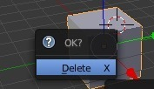

Then press shift+A to Add any item. I choose Mesh>Plane. 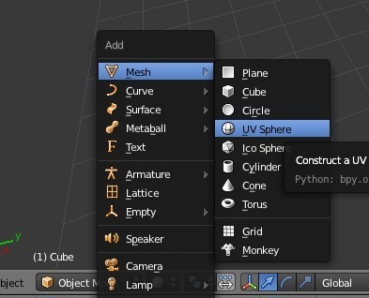

Then I select it by right click on it, and then press S to scale it. After pressing S then I click X button to scale it in X axis. And then Y button to scale it by Y axis, as well as for Z axis by clicking Z button.

I first made the surface for House. Then I need to make a Table Chair, Stair, Bedroom, Bed, Sofa, Tv, Toilet, Shoes case.

Then I need to combine them and make them into a inside house environment. So in order to do that I make Table with Plane Mesh.

To do that I select plane , then went to edit mode. I press Tab key. Also I can goto edit mode like this-

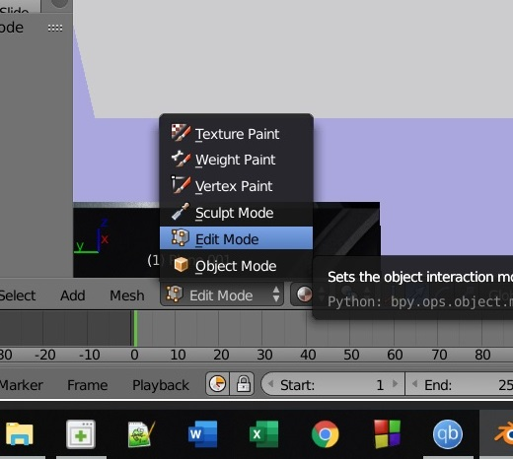

Then I press E button to extend it . I use E button with X button to extend it in X axis as much as I need.

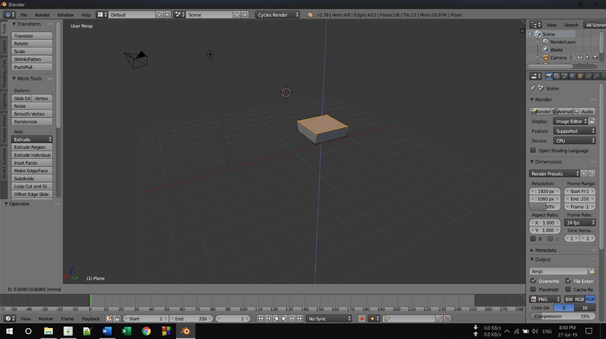

Then I zoom in that object and press ctrl+R to cut the object . Now I can select each small face and move it accordingly to my needs.

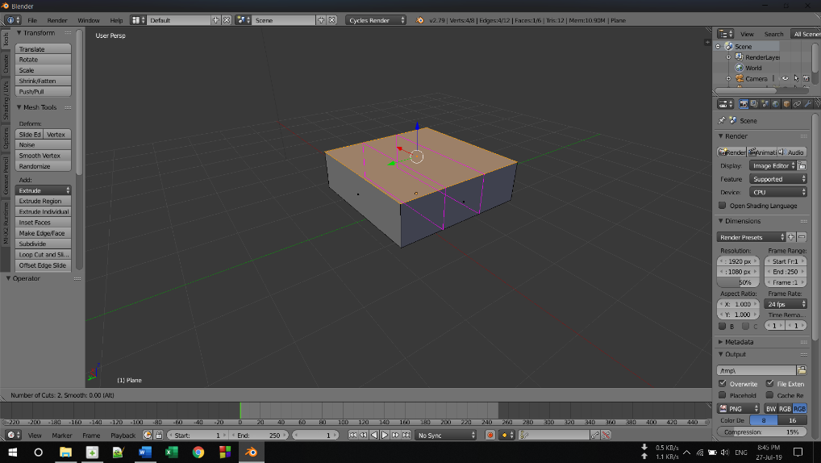

Now select face in bottom. And select corner face.

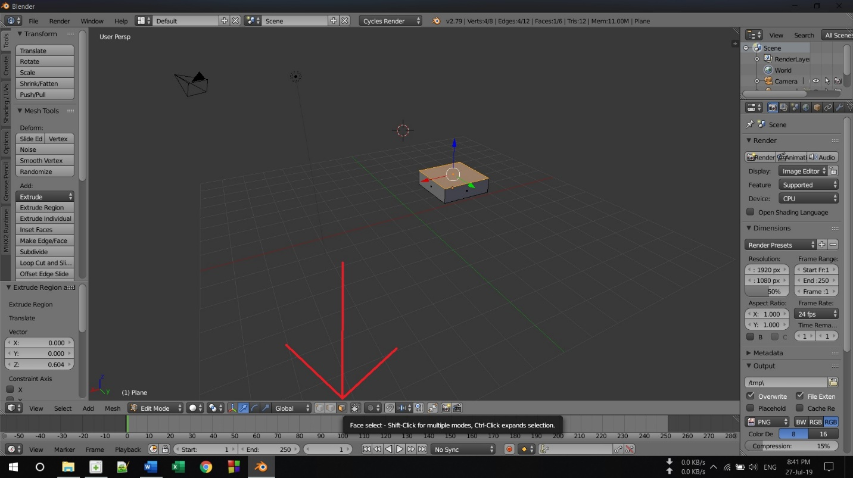

Select multiple face with shift holding and right click on it.

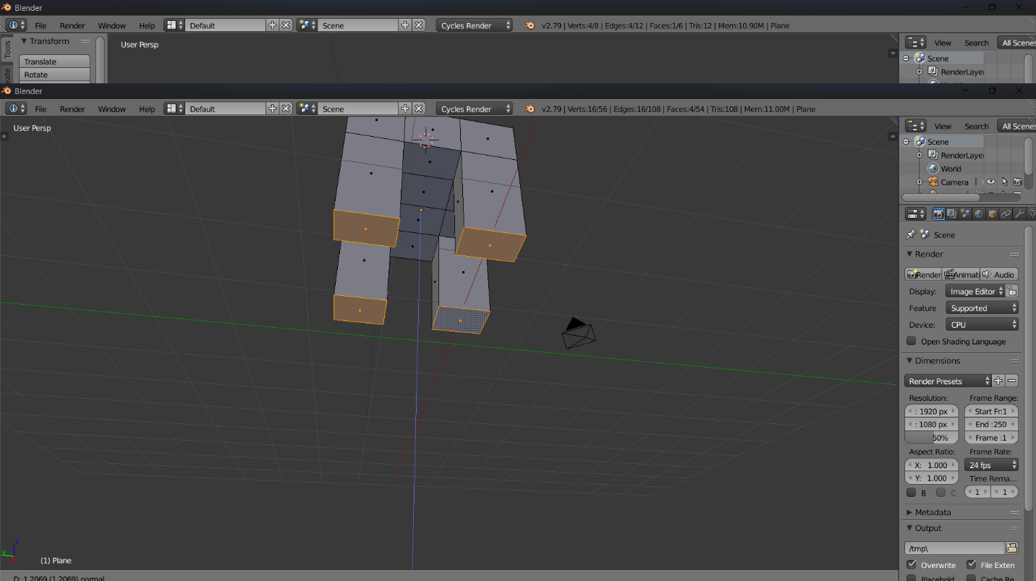

Move the camera or view by clicking middle mouse button. Also to move the focus I press shift + middle mouse button.

After that select the upper corner face to look more like a chair. Press E button to extend it.

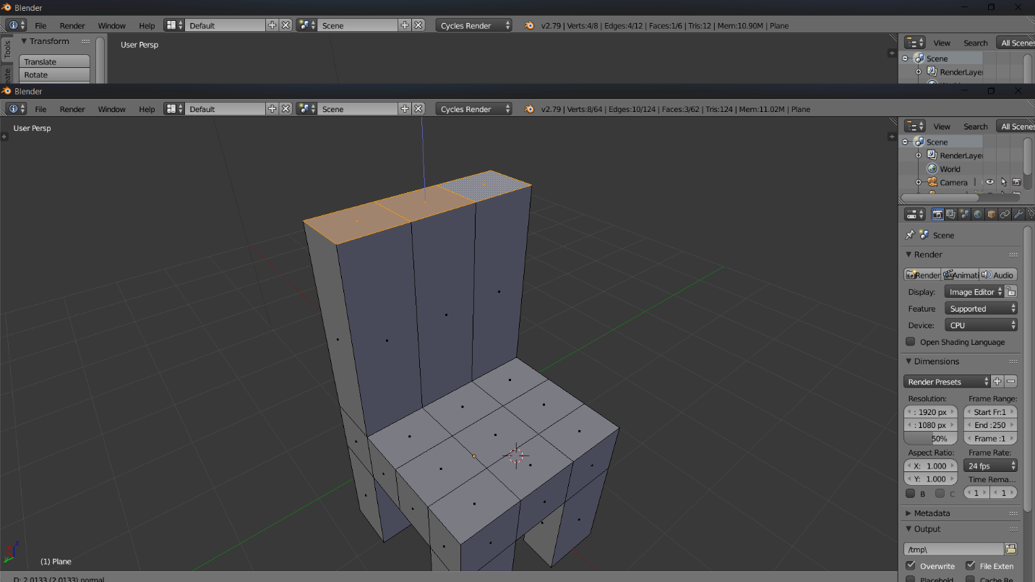

Now to make it look like a stylish chair I need to gap the chair in middle. To do that I select middle face and then click X button. Click delete. Also I select face hat needs to be delete. And deleted it.

Now I select edge to select object in edge mode. I select two inside edge with shift pressing on it. Then click F button to fill the gap with face. Also I do the same with other pair of edge .

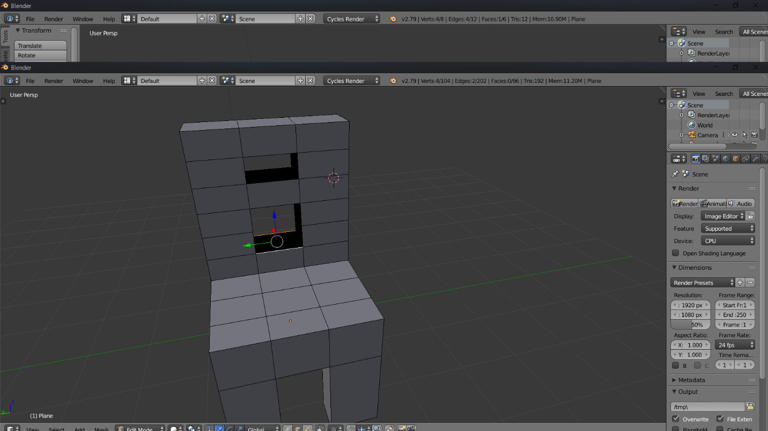

After pressing F it fill the gap with face like this below

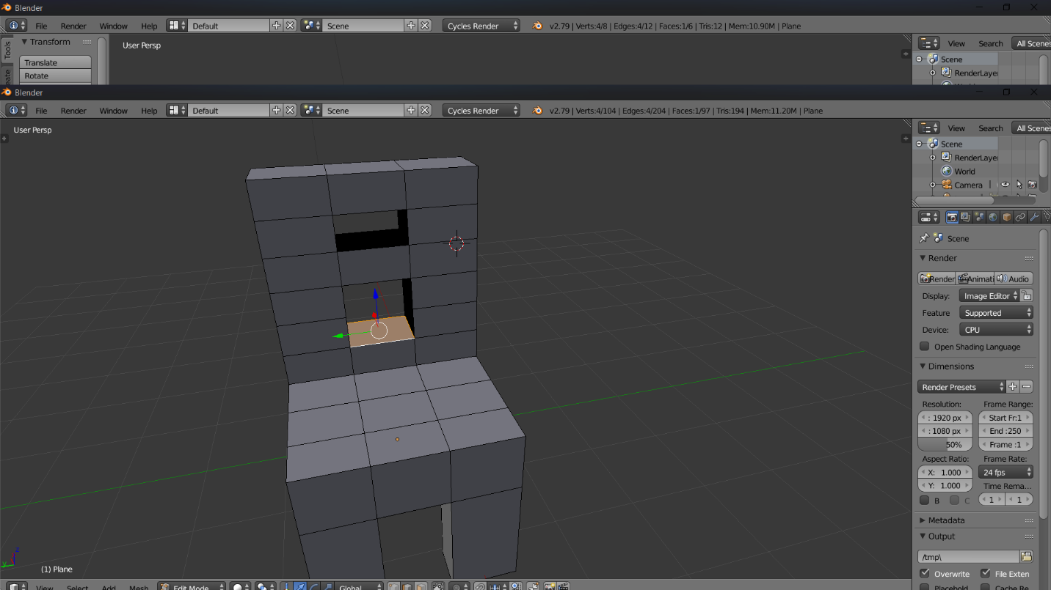

**Color & Textures**

After that I need to color that chair. In order to do that I open another two window and bring UV Image Editor & Node editor. Also I select texture mode from below.

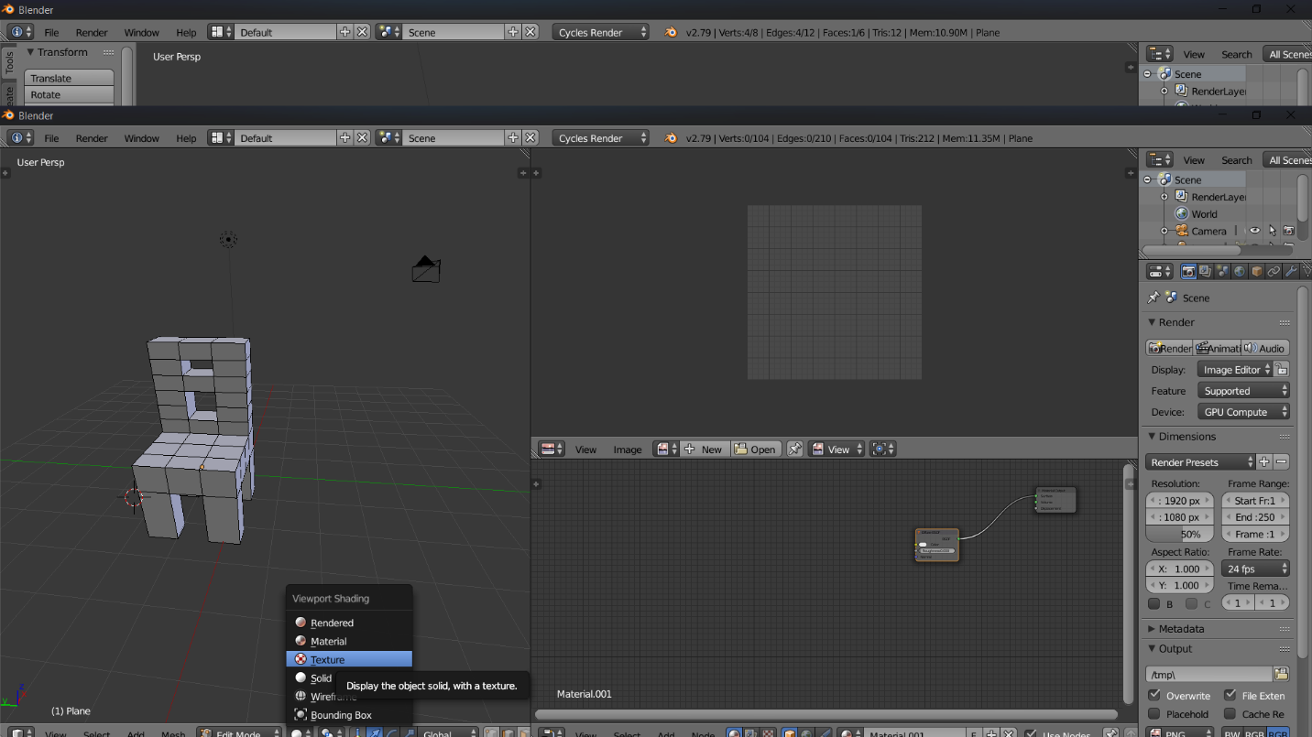

Then I select object with A button. Then click U button and select unwrap.

Then Drag any picture you like for chair and drop it in the node editor. Then connect the line between image texture and diffuse. Now I can see it take the color I gave.

Now deselect All with A button. Now it looks like wooden chair. Then I make a copy of this with shift+D button and drag the mouse a bit. Now we have two chair with same model and same color.

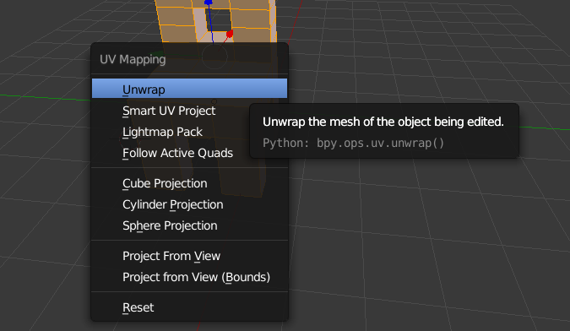

Drag and Drop photo and join the line between image texture and diffuse.

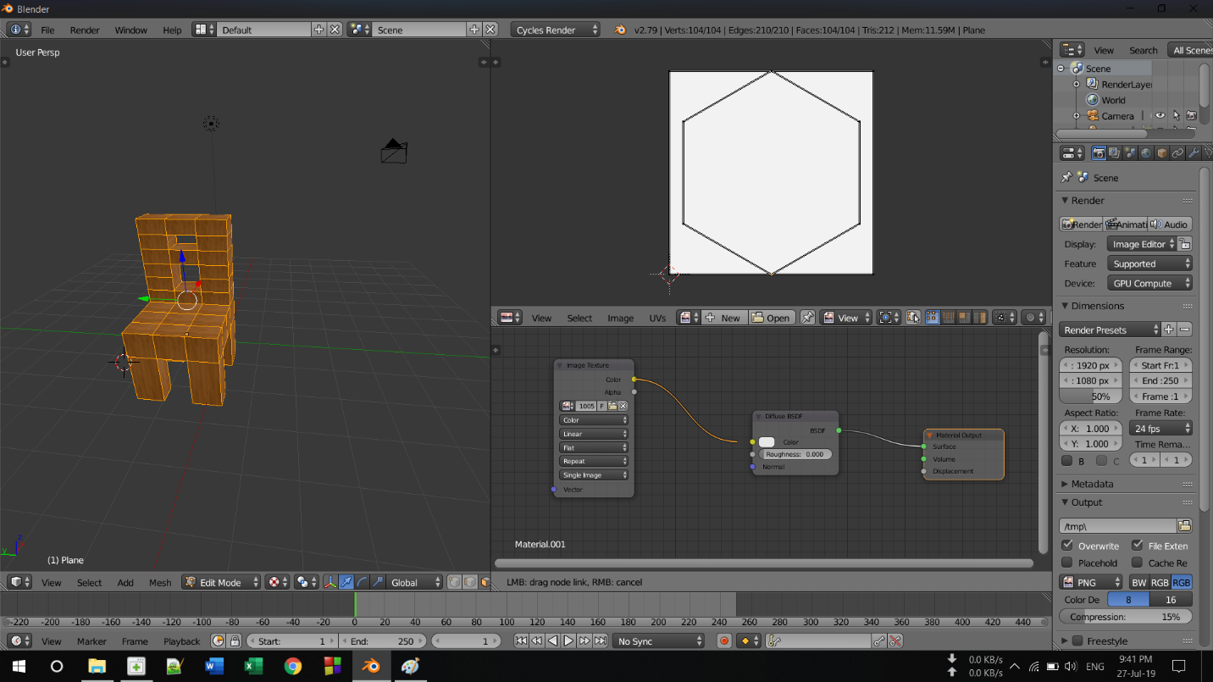

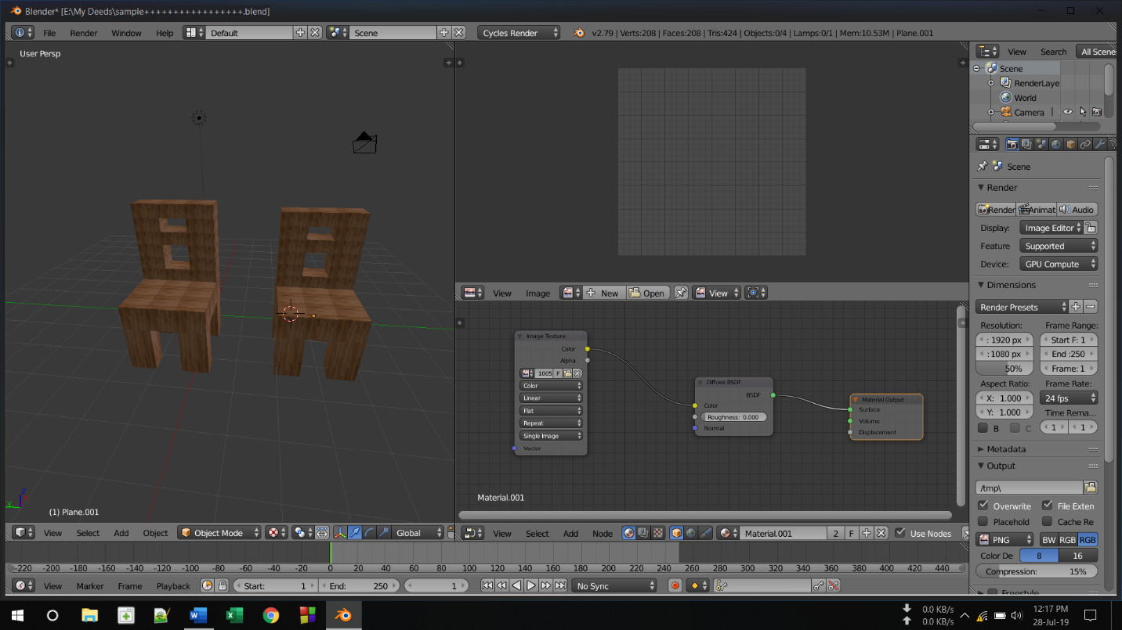

Now I have to make Dining table . I made dining table with those technique & shortcuts.

I again add mesh by clicking shift+A and this time I used cube. Now I need to make Bedsheet. For that I use E button to extend like normal Bedsheet. And then use S button to scale it.

I also make TV, Bedroom, Stairs, shoe case, sofa. Also color and texture them with those method. After Completing All these. I joined them and make them looks like inside house structure.

After joining them it looks like this. I take all angle for viewer to look better.

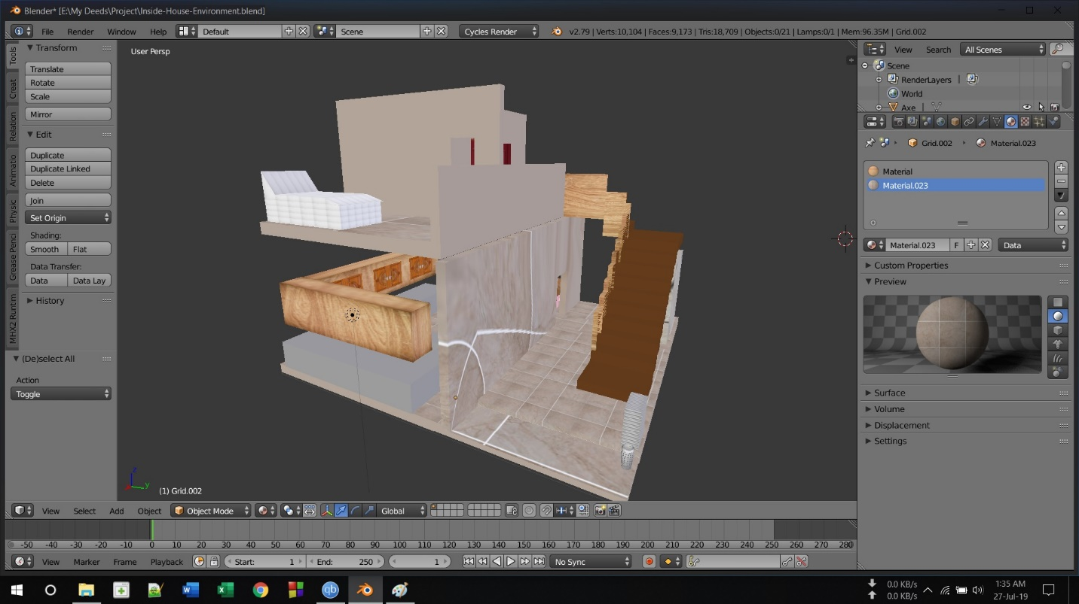

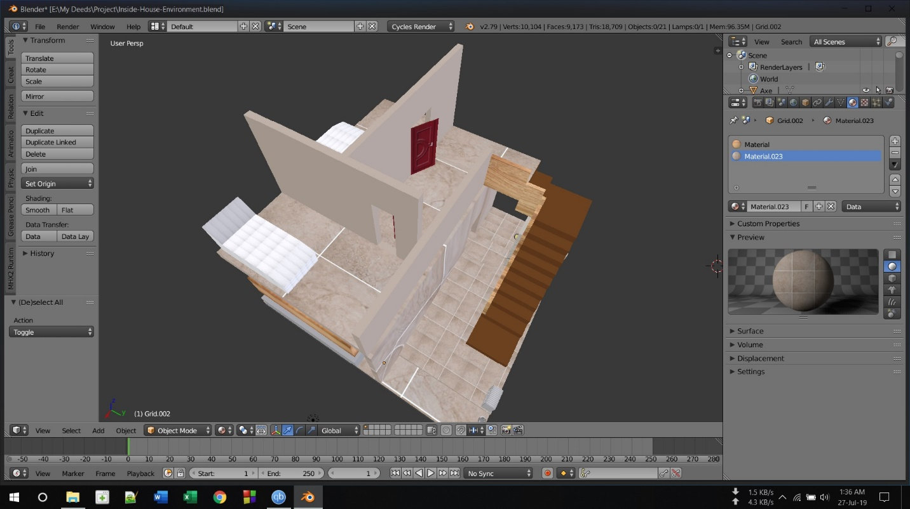

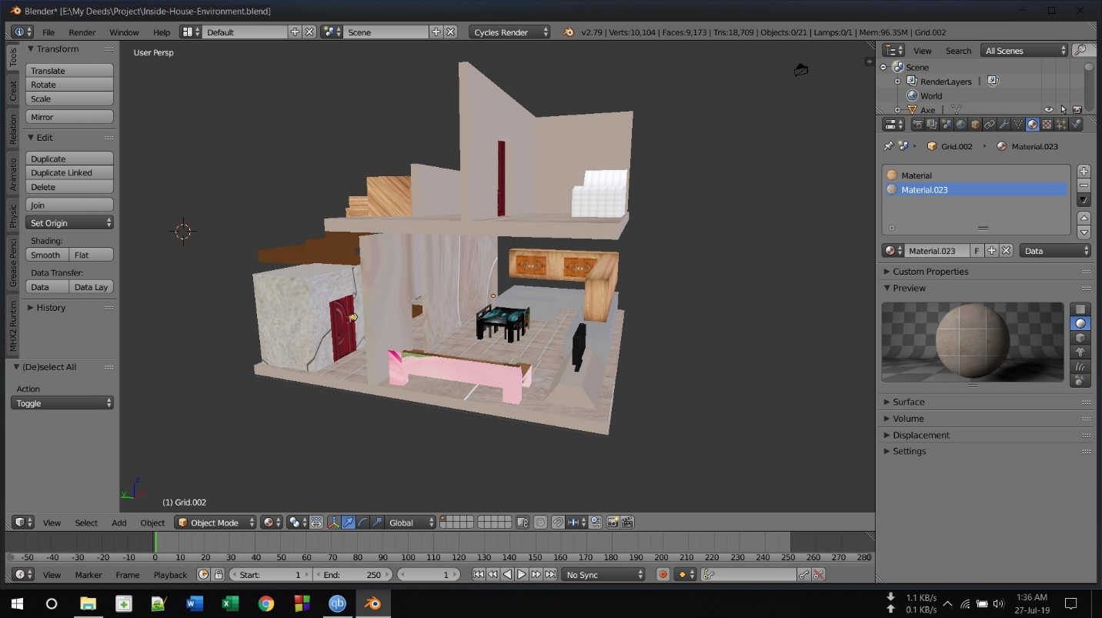

After that I make the boundaries & roof top for that house. Color that and add it like this.

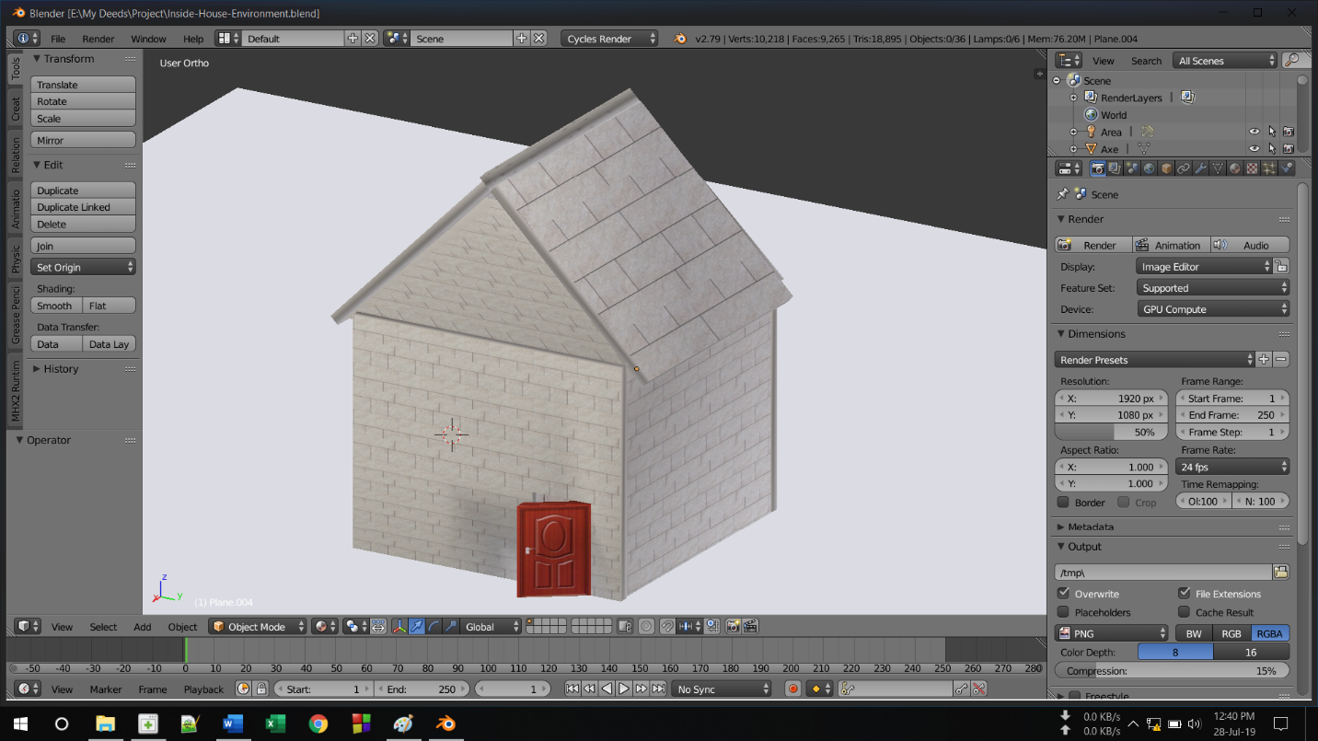

And that’s my project.

**Conclusion**

After completing my project on Blender Environment I learn how a 3D model looks like in viewer point of view. And not to mention, I learn how i can make a 3D model with this software and add texture or color to that object. I also learn various Blender Shortcuts through the process.

I wanted to show how japanese rural house looks like from inside. So this project will benefit for study of house of the rural area, then they can improve those people from their current situation.

Finally it is helpful for me to work on Blender as I learn many things about 3D modeling. I hope and pray I can make best use of my skill.